Colegio Tecnológico Worksheet 4th grade of high school
NOMBRE_____________________________FECHA______
El objetivo de esta actividad es que el estudiante sepa como hacer preguntas indirectas utilizando verbos modales como can, could, con la ayuda de un power point explicativo.
O.A: Identificar preguntas indirectas
O.A2: Transformar preguntas directas a preguntas indirectas

- Observa las imagenes y los textos en las burbujas, escribe cuales son las indirect questions que existen en ellos.

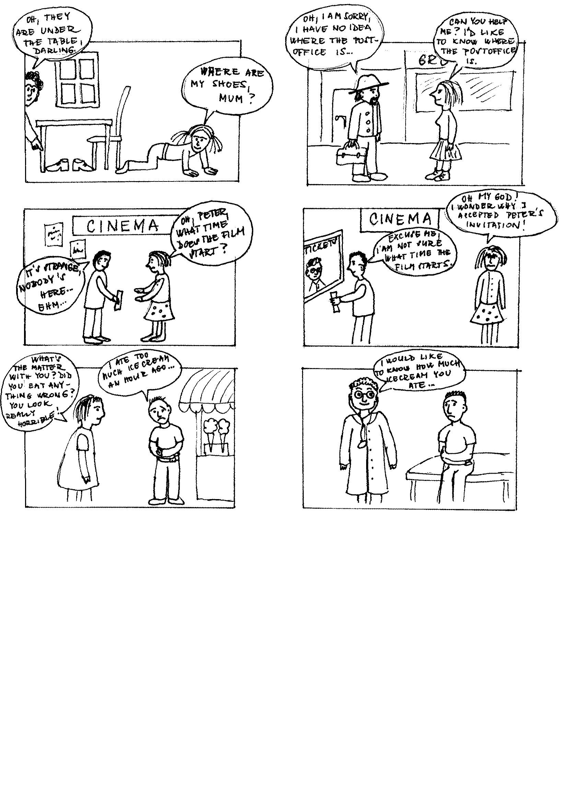
It’s strange. Nobody’s here...

Oh my God! I wonder why I accepted Peter’s invitation.

What’s the matter with you, John? Did you eat too much ice-cream?

They are under the table, darling.

Where are my shoes, mum?

They are under the table, darling.

Do you know where my shoes are, mum?

Oh, Peter! What time does the film start?

Excuse me. Can you tell me what time the film starts?

I have a horrible stomachache.

Can you remember how much ice-cream you ate?

________________________________________________________________________________
________________________________________________________________________________
________________________________________________________________________________

- Señala que preguntas son directas (direct questions) y que preguntas son indirectas (indirect questions)

- Where is the supermarket: _______________________ 2. Can you remember her name? _____________________
- Can you tell me when the class starts? _______________4. Could you tell me what her name is? ________________
5. Do you know how to get to the station? ___________________6. When is your birthday? ____________________

- Transforma las preguntas directas a preguntas indirectas, usando las expresiones para hacer preguntas indirectas y la forma correcta.
- Can you tell me…?
- Can you remember…?
- Could you tell me…?
- Do you know…?
- Can i ask you….?
- What is this?
________________________________________________________________________
- Where is the station?
_________________________________________________________________________
- When is the class?
_________________________________________________________________________
- How old are you?
_________________________________________________________________________
- Who is your best friend?
_________________________________________________________________________

